Welcome!

This is a practical quiz of your data science, visualization, and communication skills. It covers a broad range of topics, and and we don’t expect you to get every question 100% right. Feel free to use external resources like Google or a calculator. This quiz will be timed, so try to set aside three hours to take it. We’re not strict about how long you take to complete the quiz, but every extra 15 minutes that you take beyond 3 hours will subtract 5 points from your score. There are 123 possible points on the quiz. Good luck!

1. Performance Issues (12 points)
You’re running an analysis job on your favorite distributed big data platform (Spark, Hadoop, Presto, etc…) and you notice that the job is taking far more time than it usually does.

What could have happened at the software or system level? List at least 3 possibilities, and the tools/strategies you’d use to determine if each is the cause.
Answer:

2. Significance Testing (15 points)
You have yearly medical costs for 200 patients in an experimental group and for 200 in a matched control.
- Describe what you expect the yearly medical cost data to look like.
- How would you determine whether the experimental group has higher medical costs, including certainty?
- You also have access to 100 other features computed on these patients (weight, pharma cost, number of refills,... ) and have been asked by a client to determine which of these features differ between the two groups. How do you go about this task?
Answer:
- The data would be a time series with 400 times N rows where N is how many years on average we have for each patient.
- The immediate solution that comes to my mind is repeated measures ANOVA, because we have the same type of measurement (yearly costs) from the same patient repeatedly. One disadvantage of this approach is that we cannot have missing data, because ANOVA does not tolerate missing data. We could i) impute the missing values (such as use the average of available data points before and after the missing data) ii) discard the data. I also heard that general linear models (GLMs) better tolerate missing values, I don’t have much experience with that.
- We could run a two-way repeated measures ANOVA, with time and all other 100 factors as explanatory variables. However, given that we only have 400 patients we may not have enough power and the model may not converge. So I would actually propose a forward selection procedure. We could test all variables one by one, then include them in the final model only if they achieve a certain level of significance ( such as alpha=0.05). Once we have all the significant ones, I would combine them in the final model and still drop the ones that are not significant.

3. Machine Learning (20 points)
You are trying to build a predictor for a rare disease from features computed on a large labeled population. There are 1K positive cases out of 100K patients and we have 400 features computed for each patient.
- What considerations go into building your prediction pipeline?
- Propose a specific pipeline (model and training/testing setup).
- How would you report the results of your predictive algorithm to a clinical researcher?
Answer:
- Two considerations would be unbalanced data set, and the correlated features. Unbalanced dataset would make the learning difficult. The correlated features would make the model coefficients unstable and unreliable if we were to use some kind of linear model.
- I would split my data into three; training, testing, such 0.7, 0.3 split. I would first start by looking at the some of the main features and see if the data is clean. For example does age of subjects make sense? Are there any missing values and what are we going to be with them etc. Given that we have only 1000 positive samples, I would try to impute missing values. We also need to explore highly correlated features. For continuous features we could variation inflation index (VIF), for categorical variables we would try chi-square test and for continuous-categorical we could try ANCOVA. BUT, I do think that there is a better way of dealing with correlated features using L1 regularization. If we were to use regularization we would need to normalize our variables into same range (such min-max normalization). Next we have to decide what kind of model we are going to use. Let’s say we are using a linear model; we would need to convert categorical variables into dummy variables ( one-hot encoding). Next we can build the model and the determine the important coefficients using L1 regularization. To determine regularization coefficients and other model parameters, I would perform cross-validation using my validation data. Then I could measure model performance using AUC of and ROC curve. Similarly we could try non-linear model such random forests aor gradient boosted trees. The flow would not change much but i) we don’t need one-hot encoding ii) it would be better if continuous variables are discretized to prevent too many splits.
- I would report my AUC, which should be higher than 0.5 and close to 1 for a good model. I could also show them my ROC curve, which will show them the relationship between true positive rate and false positive rate. Based on this curve they can also choose a threshold for the model depending on what is more important such as not missing a deadly disease or not causing unnecessary false positive and extra diagnostic tests.

4. Freeform Exploration (30 points)
Take a look at TABLE_III._Deaths_in_122_U.S._cities.csv from data.gov. Imagine that your job is to quickly create an executive summary of the dataset for the CEO of a major nonprofit. Create a few plots for it showing a high level overview of the data with a sentence or two explaining each plot. Also create plots highlighting one or two insights in the data that you think are particularly interesting. For bonus points, create a simple interactive plot exploring some aspect of the data. Shoot for about an hour on this problem. Don’t worry too much about finer aesthetic points like colors or perfect axis labels, we’d rather see you finish quickly than slowly with perfect plots.

You can insert plot images & text right here, or attach a pdf / html / ipython notebook / whatever document if you prefer. Please also include your code in whatever format is most convenient.
Answer:
The data appears to be the number of deaths in 2016 for the first 39 weeks. In a first pass, I noticed that there are rows with regions named ‘Total’ and ‘Total_’ so I removed these rows. Then plotting the number of deaths vs time. I saw that there is a seasonal decrease in number of deaths.
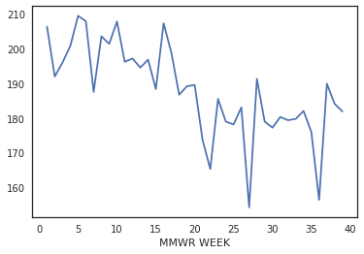
Probably number of deaths are decreasing in summer months. Then I check if this could be due less number of reporting regions in winter vs summers, but number of reporting regions do not change by weeks. Then I looked at PI (pneumonia or influenza) deaths and there is a strong seasonality here too:
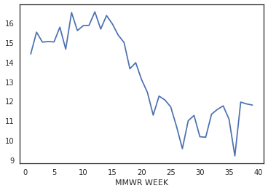
But interestingly this does not account for the whole seasonality, because even when you subtract PI deaths there is seasonality:
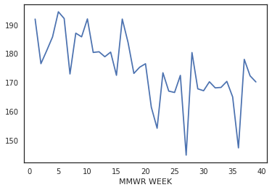

Then I looked at number of deaths in each age group vs weeks. First I did a sanity check by adding the number of deaths in age group and total is very similar to 'All causes, by age (years), All Ages**' variable. Then I found that most number of deaths are due to deaths in older than >65 group.
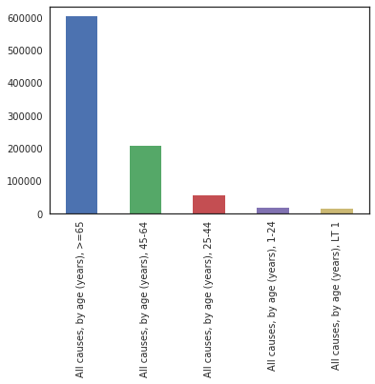
There is seasonality in older group as well but not in other groups.
Older group:
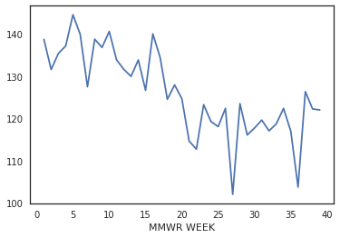

Other groups:
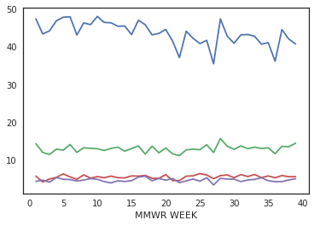
All in all, I concluded that old people are most susceptible to dying in the winter months.

BONUS: Please see interactive plot created using bokeh and the code at the end of jupyter notebook.

Code:
Please see jupyter notebook cell labelled Question 4

5. Time Series Exploration (25 points)
Take a look at timeseries_users.csv and timeseries_events.csv. This problem will be working with those files, and you can use whatever tools you think are most appropriate.

Plot a histogram of total number of events per user for all male users who are 30+ years old.
Plot:
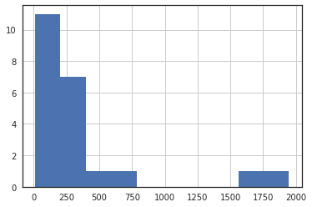
Code:
event_data = events.merge(users,on='user_id',how='left')
event_data[(event_data.age>=30)&(event_data.gender=='m')].groupby('user_id').count()['event_date'].hist()

For each user, compute the list of inter-event intervals in days. An inter-event interval is the period of time between an event and the one directly before it in time for the same user. Once you have a list of all the inter-event intervals across all users, plot a histogram of them below:
Plot:
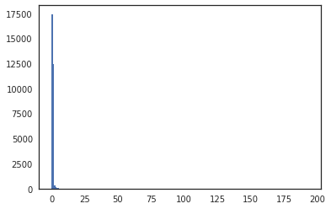

Almost half of the users have interevent interval of 0 with 12000 or so 1 and very rare high values.
Code:
Also see jupyter notebook
event_data['event_date'] = pd.to_datetime(event_data['event_date'])
interevent = []
for user_id in range(0,97):
interevent.extend(event_data[event_data.user_id==user_id].sort_values('event_date')['event_date'].diff().dt.days.dropna().tolist())

6. Storage (6 points)
Sort these by how long it takes to read one random byte of data: SSD, HDD, CPU L2 cache, S3 (accessed from your laptop), redis*, RAM.

*Assume that the redis server is running on a separate machine in the same building as your client, and that the server and client have a wired ethernet connection between them.
Answer:
My best guess is CPU L2 cache>RAM>SSD>HDD>redis>S3

7. Observational Studies (15 points)

We have a dataset of patients for which we have medical data (e.g., what conditions they have been diagnosed with, what medication they are on) and lifestyle (e.g., whether they are using a tracker and which one, how many steps they take per day, etc.)
We’re running a regression model to find variables correlated with different treatments on a diabetic cohort over the last 4 years. The model surfaces an unexpected result: Apple Watch users are significantly more likely to use TreatmentX.

What next steps would you take before drawing any conclusion on the nature of the association discovered?

Answer:
First question I would ask would be how is this correlation determined? By running univariate models or by multivariate models? If it is a univariate model we would need additional effort to convert this univariate model into a multivariate model to see if there is a significant correlation when we include other variables. More simply we could also make a histogram of several variables comparing Apple Watch users vs. Non-apple watch users to try to find reasons why are they more likely use Treatment X. Could it be that they have more diagnosis X and that’s why they are using treatment X? Could it be that Apple watch users are running more and they have athletes feet and they are using Treatment X for that?

